目录

Nginx相关配置 2

1.1、 Nginx命令 2

1.2、 Nginx集群配置 2

1.3、 Nginx反向代理(解决跨域问题) 3

# Nginx相关配置

## Nginx命令

|  |
| --- |
| #启动  start nginx  #停止(第一种)  nginx -s stop  #停止(第二种)  nginx -s quit  #重启  nginx -s reload  #重新打开日志文件  nginx -s reopen |

## Nginx集群配置

修改config/nginx.conf文件配置

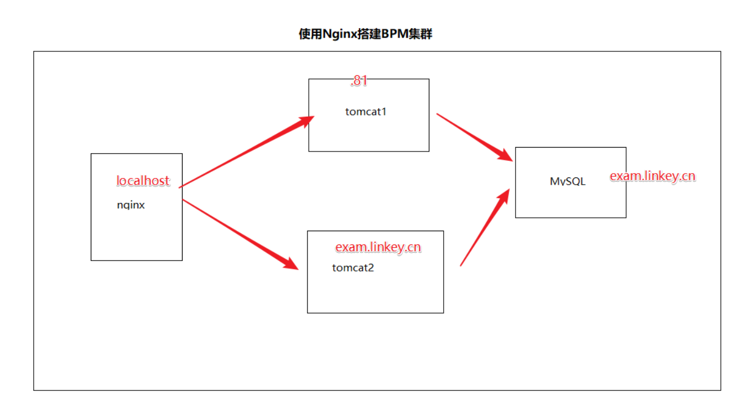

|  |
| --- |
| http {  include mime.types;  default_type application/octet-stream;  #log_format main '$remote_addr - $remote_user [$time_local] "$request" '  # '$status $body_bytes_sent "$http_referer" '  # '"$http_user_agent" "$http_x_forwarded_for"';  #access_log logs/access.log main;  sendfile on;  #tcp_nopush on;  #keepalive_timeout 0;  keepalive_timeout 65;  #gzip on;    #add by alibo 集群配置服务器 ip_hash表示同一个IP指向同一服务器处理  **upstream localhost{**  **ip_hash;**  **server 212.64.55.81;**  **server exam.linkey.cn;**  **}**  server {  **listen 80;**  **server_name localhost;**  #charset koi8-r;  #access_log logs/host.access.log main;  **location / {**  **#root html;**  **#index index.html index.htm;**  **#对上面upstream localhost进行监听**  **proxy_pass http://localhost;**  **}**  #error_page 404 /404.html; |

## Nginx反向代理(解决跨域问题)

|  |
| --- |
| http {  include mime.types;  default_type application/octet-stream;  #log_format main '$remote_addr - $remote_user [$time_local] "$request" '  # '$status $body_bytes_sent "$http_referer" '  # '"$http_user_agent" "$http_x_forwarded_for"';  #access_log logs/access.log main;  sendfile on;  #tcp_nopush on;  #keepalive_timeout 0;  keepalive_timeout 65;  #gzip on;  server {  **listen 80; #监听端口**  **server_name 127.0.0.1; #监听域名**  #charset koi8-r;  #access_log logs/host.access.log main;  #add by alibao  **location / {**  **proxy_pass http://127.0.0.1:8020; #访问服务器**  **proxy_redirect default;**  **}**  #error_page 404 /404.html;  # redirect server error pages to the static page /50x.html  #  error_page 500 502 503 504 /50x.html;  location = /50x.html {  root html;  }  **location /apis { #添加访问目录为/apis的代理配置**  **rewrite ^/apis/(.*)$ /$1 break;**  **proxy_pass http://exam.linkey.cn:6660;**  **}**  # pass the PHP scripts to FastCGI server listening on 127.0.0.1:9000  # |